UNITED STATES
SECURITIES AND EXCHANGE COMMISSION
Washington, D.C. 20549
SCHEDULE 14A
(Rule 14a-101)
Proxy Statement Pursuant to Section 14(a) of the Securities Exchange Act of 1934
(Amendment No.)
Filed by the Registrant ☒ Filed by a Party other than the Registrant ☐
Check the appropriate box:

☐ | Preliminary Proxy Statement
☐ | Confidential, for Use of the Commission Only (as permitted by Rule 14a-6(e)(2))
☐ | Definitive Proxy Statement
☒ | Definitive Additional Materials
☐ | Soliciting Material under §240.14a-12

Culp, Inc.
(Name of Registrant as Specified In Its Charter)
(Name of Person(s) Filing Proxy Statement, if Other Than the Registrant)
Payment of Filing Fee (Check all boxes that apply):

☒ | No fee required.
☐ | Fee paid previously with preliminary materials.
☐ | Fee computed on table in exhibit required by Item 25(b) per Exchange Act Rules 14a-(6)(i)(1) and 0-11

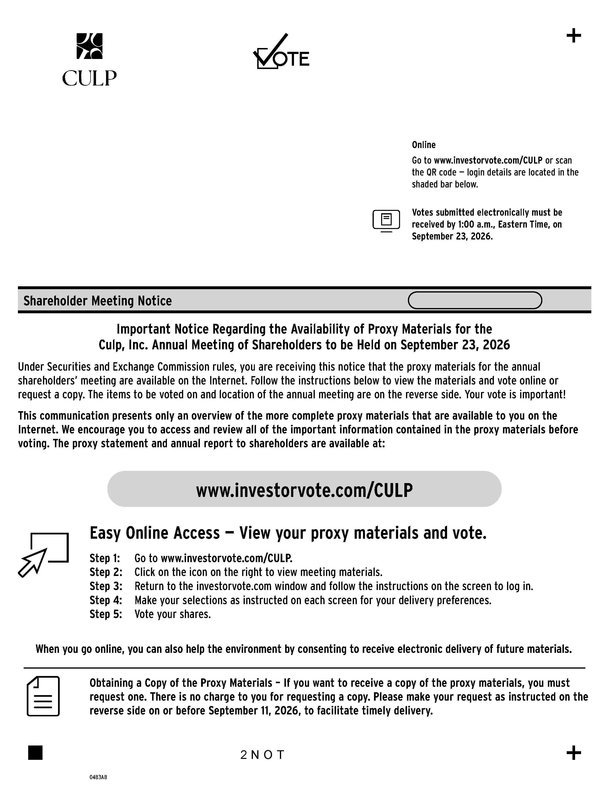

Online Go to www.investorvote.com/CULP or scan the QR code — login details are located in the shaded bar below. Votes submitted electronically must be received by 1:00 a.m., Eastern Time, on September 23, 2026. Shareholder Meeting Notice Important Notice Regarding the Availability of Proxy Materials for the Culp, Inc. Annual Meeting of Shareholders to be Held on September 23, 2026 Under Securities and Exchange Commission rules, you are receiving this notice that the proxy materials for the annual shareholders’ meeting are available on the Internet. Follow the instructions below to view the materials and vote online or request a copy. The items to be voted on and location of the annual meeting are on the reverse side. Your vote is important! This communication presents only an overview of the more complete proxy materials that are available to you on the Internet. We encourage you to access and review all of the important information contained in the proxy materials before voting. The proxy statement and annual report to shareholders are available at: Easy Online Access — View your proxy materials and vote. Step 1: Go to www.investorvote.com/CULP. Step 2: Click on the icon on the right to view meeting materials. Step 3: Return to the investorvote.com window and follow the instructions on the screen to log in. Step 4: Make your selections as instructed on each screen for your delivery preferences. Step 5: Vote your shares. www.investorvote.com/CULP When you go online, you can also help the environment by consenting to receive electronic delivery of future materials. Obtaining a Copy of the Proxy Materials – If you want to receive a copy of the proxy materials, you must request one. There is no charge to you for requesting a copy. Please make your request as instructed on the reverse side on or before September 11, 2026, to facilitate timely delivery. 2NOT 04B3AB

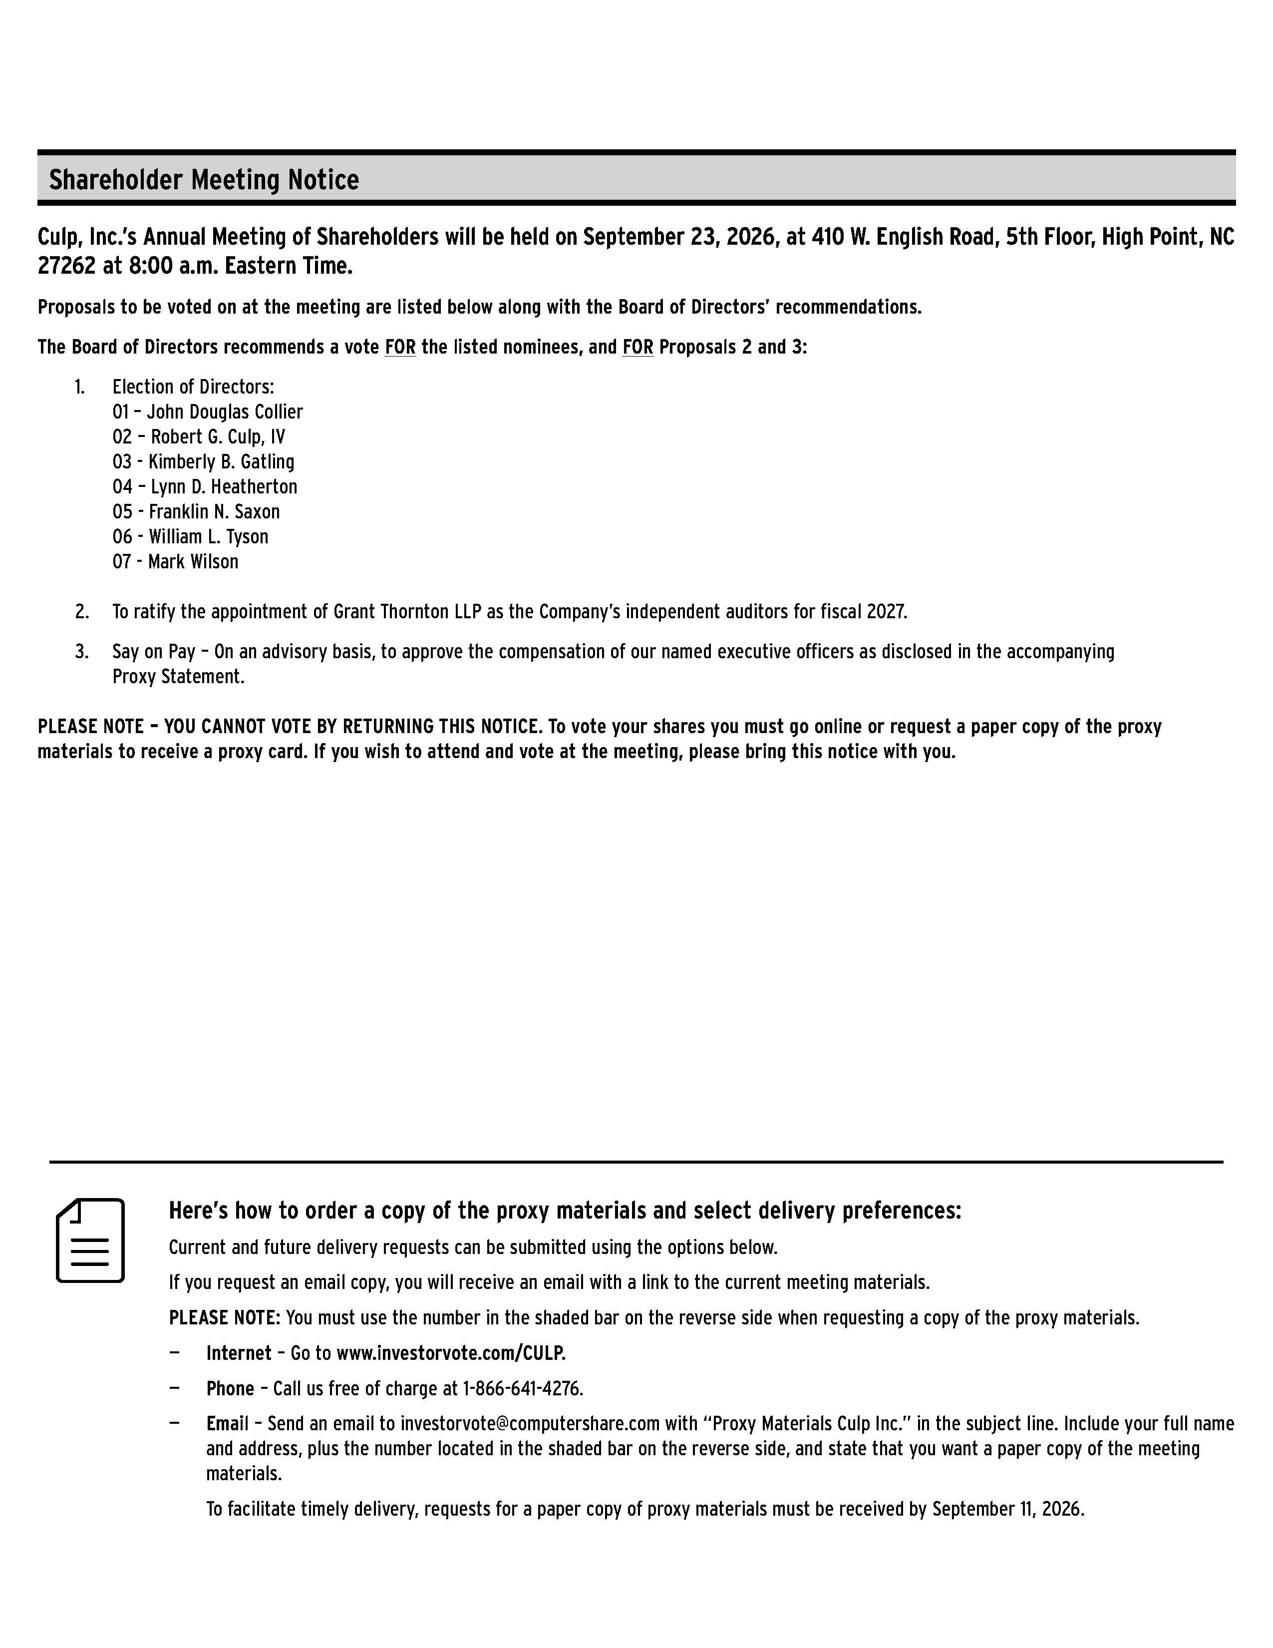

Shareholder Meeting Notice Culp, Inc.’s Annual Meeting of Shareholders will be held on September 23, 2026, at 410 W. English Road, 5th Floor, High Point, NC 27262 at 8:00 a.m. Eastern Time. Proposals to be voted on at the meeting are listed below along with the Board of Directors’ recommendations. The Board of Directors recommends a vote FOR the listed nominees, and FOR Proposals 2 and 3: 1. Election of Directors: 01 – John Douglas Collier 02 – Robert G. Culp, IV 03 - Kimberly B. Gatling 04 – Lynn D. Heatherton 05 - Franklin N. Saxon 06 - William L. Tyson 07 - Mark Wilson 2. To ratify the appointment of Grant Thornton LLP as the Company’s independent auditors for fiscal 2027. Say on Pay – On an advisory basis, to approve the compensation of our named executive officers as disclosed in the accompanying Proxy Statement. PLEASE NOTE – YOU CANNOT VOTE BY RETURNING THIS NOTICE. To vote your shares you must go online or request a paper copy of the proxy materials to receive a proxy card. If you wish to attend and vote at the meeting, please bring this notice with you. Here’s how to order a copy of the proxy materials and select delivery preferences: Current and future delivery requests can be submitted using the options below. If you request an email copy, you will receive an email with a link to the current meeting materials. PLEASE NOTE: You must use the number in the shaded bar on the reverse side when requesting a copy of the proxy materials. Internet – Go to www.investorvote.com/CULP. — Phone – Call us free of charge at 1-866-641-4276. — Email – Send an email to investorvote@computershare.com with “Proxy Materials Culp Inc.” in the subject line. Include your full name and address, plus the number located in the shaded bar on the reverse side, and state that you want a paper copy of the meeting materials. To facilitate timely delivery, requests for a paper copy of proxy materials must be received by September 11, 2026.

